51. N-Queens
Hard

The n-queens puzzle is the problem of placing n queens on an n x n chessboard such that no two queens attack each other.
Given an integer n, return all distinct solutions to the n-queens puzzle. You may return the answer in any order.
Each solution contains a distinct board configuration of the n-queens' placement, where 'Q' and '.' both indicate a queen and an empty space, respectively.

Example 1:
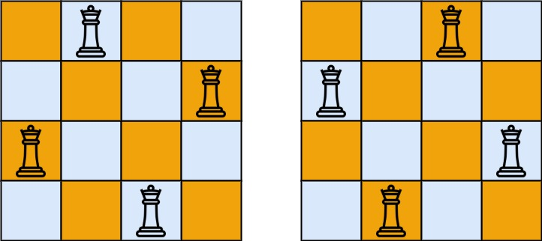
Input: n = 4
Output: [[".Q..","...Q","Q...","..Q."],["..Q.","Q...","...Q",".Q.."]]
Explanation: There exist two distinct solutions to the 4-queens puzzle as shown above
Example 2:
Input: n = 1
Output: [["Q"]]

Constraints:
- 1 <= n <= 9

